**Project Design Phase-II**

**Technology Stack (Architecture & Stack)**

|  |  |
| --- | --- |
| Date | 27 june 2025 |
| Team ID | LTVIP2025TMID59171 |
| Project Name | HealthAI: Intelligent Healthcare Assistant Using IBM Granite |
| Maximum Marks | 4 Marks |

**Technical Architecture:**

The Deliverable shall include the architectural diagram as below and the information as per the table1 & table 2

**Example: Order processing during pandemics for offline mode**  
  
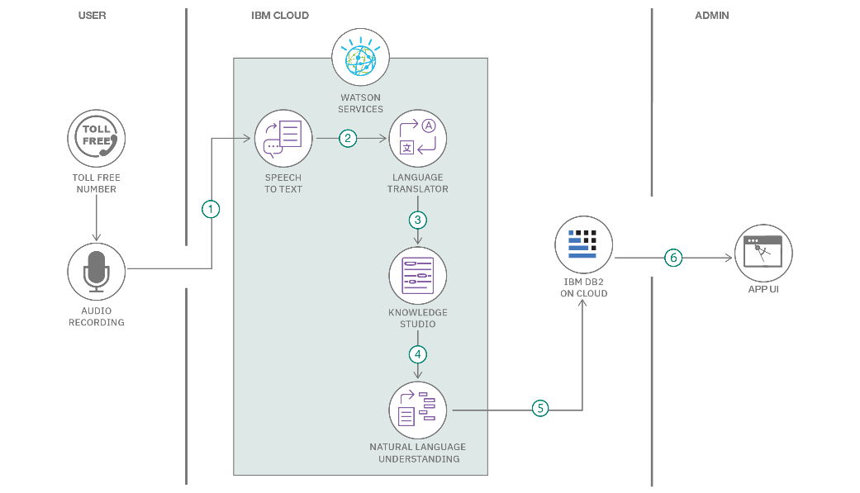

**Table-1: Components & Technologies**

|  |  |  |  |
| --- | --- | --- | --- |
| **S.No** | **Component** | **Description** | **Technology** |
| 1 | User Interface | Web and Mobile user interface with forms, chat, and health dashboards | Streamlit (Python), HTML/CSS, JS |
| 2 | Application Logic-1 | Registration, login, and dashboard logic | Python (Flask) |
| 3 | Application Logic-2 | Speech-to-text feature for patient voice inputs | IBM Watson Speech-to-Text |
| 4 | Application Logic-3 | Conversational AI for symptom analysis | IBM Watson Assistant / Hugging Face Transformers |
| 5 | Database | Stores users, health logs, vitals, chats, and predictions | MySQL (on IBM Cloud) |
| 6 | Cloud Database | Cloud-based backup and data sync | IBM Cloudant |
| 7 | File Storage | Store user reports, chat logs, audio files | IBM Cloud Object Storage |
| 8 | External API-1 | Health-related news, weather condition if relevant | IBM Weather API |
| 9 | External API-2 | Aadhar verification API (for patient validation) | Aadhar eKYC API |
| 10 | Machine Learning Model | AI model to predict diseases based on symptoms | IBM Granite 13B / Hugging Face Transformers |
| 11 | Infrastructure | Deployment in the cloud for scalability and uptime | IBM Cloud Foundry / Kubernetes |

**📊 Table-2: Application Characteristics**

|  |  |  |  |
| --- | --- | --- | --- |
| **S.No** | **Characteristics** | **Description** | **Technology** |
| 1 | Open-Source Frameworks | Frontend and backend based on open technologies | Streamlit, Flask, Hugging Face Transformers |
| 2 | Security Implementations | SHA-256 for password encryption, IAM roles, HTTPS, OAuth2 login | OpenSSL, JWT, IBM IAM, OAuth 2.0, HTTPS |
| 3 | Scalable Architecture | 3-tier model with possible microservices expansion | Kubernetes, IBM Cloud Container Services |
| 4 | Availability | Load balancers and redundant instances for maximum uptime | IBM Cloud Load Balancer, Multi-zone deployments |
| 5 | Performance | Caching for repeated API calls, optimized queries, minimal AI response time | Redis Cache, CDN (Cloudflare), MySQL indexing |

**Reference Links**

1. **IBM Developer – AI-Powered Backend for Order Processing During Pandemics**  
   <https://developer.ibm.com/patterns/ai-powered-backend-system-for-order-processing-during-pandemics/>
2. **IBM Developer – Healthcare Chatbot Architecture**  
   https://developer.ibm.com/patterns/healthcare-chatbot-architecture/
3. **IBM Cloud Architecture Center**  
   <https://www.ibm.com/cloud/architecture>
4. **C4 Model – Visualizing Software Architecture**  
   <https://c4model.com/>
5. **AWS Architecture Center**  
   <https://aws.amazon.com/architecture/>
6. **Medium – How to Draw Useful Technical Architecture Diagrams**  
   <https://medium.com/the-internal-startup/how-to-draw-useful-technical-architecture-diagrams-2d20c9fda90d>